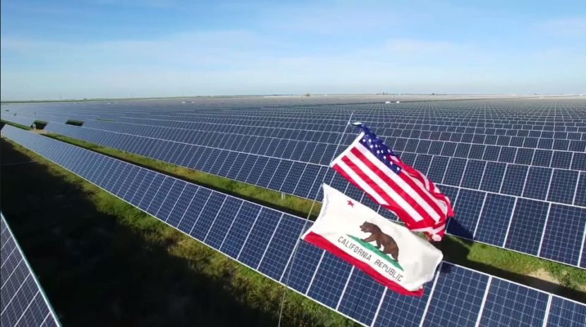

**Solar Energy in California**

Los Angeles 03.02.2019

University of Southern California

Data Analytics Certified Program

Adriana Rubalcaba, Dylan Kaiser, Anna Miller

**Table of content:**

Hypothesis 3

Abstract 4

Interesting facts 5

Data analysis 6

Summary

Resources

**Hypothesis**

If the climate zone is different, then the number of installations stays the same.

If the temperature in particular climate zone is higher the size of solar energy installation is bigger.

If the climate zone is colder then there are less installations during winter.

If the climate zone is warmer the cost of solar energy installation decrease.



**Abstract**

# There are no doubts the solar energy market is growing faster than ever. Decreasing cost of installation and the environmental benefits attract new groups of customers.

# Our goal was to find useful information that would help us to make conclusions and support decision making process based on scientific data.

# At the beginning we have tried to determine …..

# We also wanted to find out whether …..

# We did some comparison between……

# Our group inspected the data by ….

# We cleaned our data using…

# (describe the transformation and modeling data process)

# Health & Environmental Benefits of Solar Energy

Most of the electricity generated in the U.S. comes from fossil fuels like coal and natural gas. Extracting and using fossil fuels is expensive and harmful to the environment. Greenhouse gases, particularly carbon dioxide (CO2), which are produced when fossil fuels are burned, lead to rising global temperatures and climate change.

Oils may not contribute to global warming on the same scale as coal, but each year in America alone, over one million gallons of petroleum spill into waterways, oceans, and groundwater.

One of the biggest benefits of solar energy is that it results in very few air pollutants. Generating electricity with solar power instead of fossil fuels can dramatically help the environment.

A household [rooftop solar panel system](https://www.solarpowerauthority.com/guide-to-solar-shingles/) can reduce pollution by 100 tons of CO2 carbon dioxide in its lifetime—and this includes the energy it took to manufacture the solar panels.Solar panels can improve future air quality for humans as well as the millions of birds, fish, and mammals that are negatively affected by pollution each year.

An [analysis](http://www.nrel.gov/docs/fy07osti/41998.pdf) by the National Renewable Energy Laboratory (NREL) found that widespread solar adoption would results in fewer cases of chronic bronchitis, respiratory and cardiovascular problems, and lost workdays related to health issues.

**Interesting Facts**

“If we could capture all of the sun’s energy shining on the Earth for just one hour, we could power the entire world for one year!”

Our sun has been shining for over four and a half billion years. However, humans have only known about solar power since the 1830s, when Alexandre Edmond Becquerel discovered the photovoltaic effect that generates electric current.

## How solar power harnesses the natural energy of the sun to produce electricity?

## Basically, sunlight takes a little over eight minutes to reach the Earth and a few seconds longer to make contact with the solar panels. When that happens solar cells capture certain distance between two waves of solar radiation and convert them to electricity for our homes, calculators, and more.

Solar panels don’t need direct sunlight to produce electricity. However, [direct sunlight produces the most energy](https://www.solarpowerauthority.com/how-to-calculate-your-peak-sun-hours/).

On the international market China has the most solar power wattage in the world—78,100 gigawatts, —followed by Japan, Germany, the United States, and Italy.

## Most solar panels have a 25-year warranty, and if you rent or lease, most companies provide free maintenance.

Some states allow you to sell the excess solar energy you produce, meaning you can not only earn back the cost of your panels but also make a profit on energy in the long run.

Solar panels are exempt from property taxes in many states and can increase the value of a home more than a complete kitchen remodel. However, you can take your solar panels with you when you move.

Until the sun fizzles out, solar power will continue to be a very reliable energy source; our ability to harvest solar power is solely dependent on technology, location, cost, and legislation.

At the moment, the state is actually [producing more solar](http://www.pe.com/2017/03/18/heres-how-california-ended-up-with-too-much-solar-power/) energy than it has the infrastructure to consume.

In 2016, there was one new solar panel installation every 84 seconds.

NASA is presently working on a solar-powered aircraft.

The first solar-powered calculators were invented in 1978.

Currently, the sun burns hydrogen. One day when all the hydrogen is gone, it will switch to helium—but that doesn’t matter for solar panels. They’ll continue to use the sun’s rays to create electricity to power our homes.

Solar power is one of the cleanest, most sustainable, and most renewable resources in the world, but in order to power the entire earth on renewable energy, we would need to install solar panels on over 191,000 square miles.Considering there are over 57million square miles of land on earth, we have room to spare.

What direction In the United States, solar panels need to face to capture optimal sunlight?

What is the biggest city in United States that operates on almost 100% renewable energy?

**Solar Jobs market.**

2016 was the best year on record for solar energy in the United States. More than 260,000 Americans worked in this industry, although a report from the U.S. Department of Energy at the time showed that solar energy was responsible for a much larger share of employment in the electric power sector (43%) than the whole of the fossil fuel industry combined (22%)

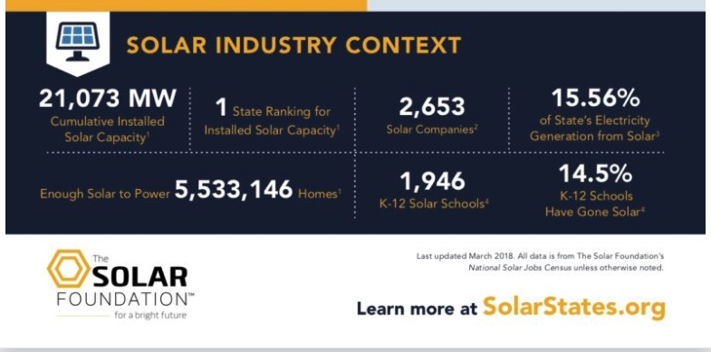

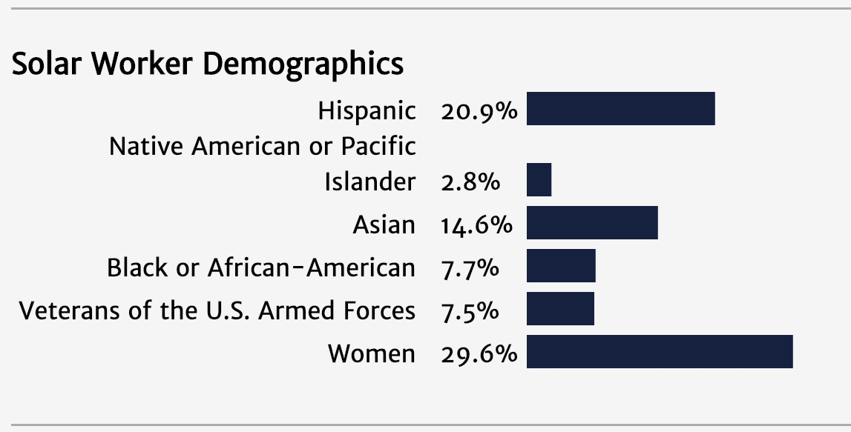

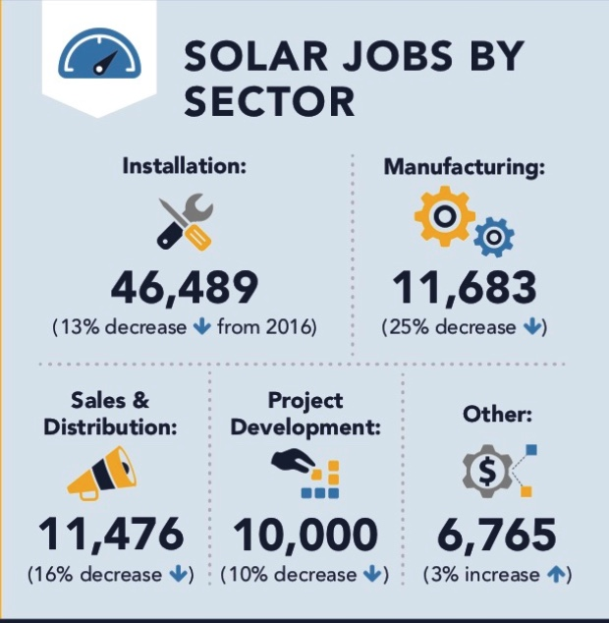

The Solar Foundation’s [latest report](https://www.thesolarfoundation.org/national/) has called the last two years “challenging”. Since that record year, the solar sector has lost close to 18,000 jobs.

Although some job losses were seen as a result of project finalizations in several states, the biggest contributing factor was tariff war with China which was the main supplier for domestic solar industry in USA.

Analysis

Solar power is measured like all electricity—in watts (kilowatts, megawatts, gigawatts, and terawatts). One thousand watts equal one kilowatt, 1,000 kilowatts equal one megawatt, 1,000 megawatts equal one gigawatt, and 1,000 gigawatts equal one terawatt.

1. Most solar panels have 200- or 250-watt capacities.
2. The majority of solar panels can produce eight to ten kilowatts of energy per square foot.
3. Most homes consume nearly 11,000 kilowatt-hours of energy each year,1 meaning that to power your entire home off the grid, you’d need upwards of 30 250-watt solar panels that get a daily average of four hours of full sunlight.

Temperature in CA

Climate zones in CA

Resources

<https://news.energysage.com/health-environmental-benefits-of-solar-energy/>

*EnergySage, “*[*How much do solar panels cost in the U.S.*](http://news.energysage.com/how-much-does-the-average-solar-panel-installation-cost-in-the-u-s/)*?”*

*Energy Informative, “*[*How Long to Pay Off my Solar Panels?*](http://energyinformative.org/long-pay-solar-panels/)*”*

*National Association of Home Builders, “*[*Average Monthly Electrical Bill by State ­– Updated Data*](http://eyeonhousing.org/2015/03/average-monthly-electrical-bill-by-state-2013/)*”*

*Energy Informative, “*[*How Long to Pay Off my Solar Panels?*](http://energyinformative.org/long-pay-solar-panels/)*”*

*Solar Energy Industries Association, “*[*Top 10 Solar States*](http://www.seia.org/research-resources/top-10-solar-states)*”*

*The Solar Foundation, “*[*National Solar Jobs Census*](https://www.forbes.com/forbes/welcome/?toURL=https://www.forbes.com/sites/ashleaebeling/2011/08/01/how-much-do-solar-panels-boost-home-sale-prices/&refURL=&referrer=#793c251429dd)*”*

*Solar Energy Industries Association, “*[*Solar Industry Data*](http://www.seia.org/research-resources/solar-industry-data)*”*

*International Energy Agency, “*[*2016 Snapshot of Global Photovoltaic Markets*](http://www.iea-pvps.org/fileadmin/dam/public/report/statistics/IEA-PVPS_-__A_Snapshot_of_Global_PV_-_1992-2016.pdf.pdf)*”*

*Conserve Energy Future, “*[*Solar Energy Facts*](http://www.conserve-energy-future.com/various-solar-energy-facts.php)*”*

1. *MIT Technology Review, “*[*First Solar’s Cells Break Efficiency Record*](https://www.technologyreview.com/s/600922/first-solars-cells-break-efficiency-record/)*”*